Creeating a BANANA table with a Primary Key BANANAID that is dependent on a SEQUENCE.

**Create the sequence**

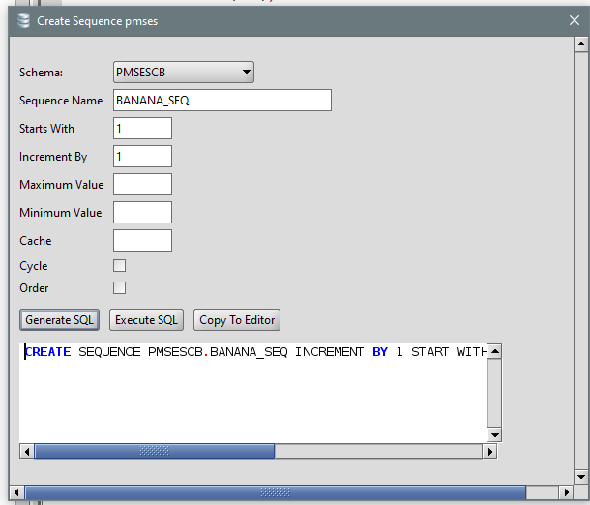

**Create the sequence**

**Create the table by copying the old table without bad fields:**

CREATE TABLE PMSESCB.BANANA(

BANANAID NUMBER(10) DEFAULT "PMSESCB"."BANANA_SEQ"."NEXTVAL" NOT NULL,

BANANANAME VARCHAR2(200),

PRIMARY KEY (BANANAID)

);

**COPY A TABLE AND MAKE PRIMARY INDEX DEPENDENT ON A SEQUENCE**

**Get the max of the primary key:**

**Select max(lbdocid) from lbdoc;**

**(result is 3634)**

**Create the sequence**

**CREATE SEQUENCE PMSESCB.”LBDOC1_SEQ" INCREMENT BY 1 START WITH 3635 NOCYCLE NOCACHE NOORDER**

**Make create table, without the troublesome fields. Note Primary Key. Note Default on Primary Key**

CREATE TABLE PMSESCB.LBDOC1 (

COLLDESCRIPTION VARCHAR2(4000),

LIBRARYID NUMBER(10),

DOCTITLE VARCHAR2(225),

LBFOLDERID NUMBER(10),

LBDOCID NUMBER(10) DEFAULT "PMSESCB"."LBDOC1_SEQ"."NEXTVAL" NOT NULL,

PARENTLBDOCID NUMBER(10) DEFAULT 0,

CLASSIFID NUMBER(10),

ORIGACTIVITYID NUMBER,

MODIFIEDBYUSERID NUMBER(10),

DATE_MODIFIED DATE,

AUTHORID NUMBER(10),

ABSTRACT VARCHAR2(4000),

PRIMARY KEY (LBDOCID)

);

**Copy the non-troublesome fields, INCLUDING the old primary key**

INSERT INTO PMSESCB.LBDOC1 FIELDS ( COLLDESCRIPTION,

LIBRARYID,

DOCTITLE,

LBFOLDERID,

LBDOCID,

PARENTLBDOCID,

CLASSIFID,

ORIGACTIVITYID,

MODIFIEDBYUSERID,

DATE_MODIFIED,

AUTHORID,

ABSTRACT)

SELECT

COLLDESCRIPTION,

LIBRARYID,

DOCTITLE,

LBFOLDERID,

LBDOCID,

PARENTLBDOCID,

CLASSIFID,

ORIGACTIVITYID,

MODIFIEDBYUSERID,

DATE_MODIFIED,

AUTHORID,

ABSTRACT

FROM PMSESCB.LBDOC;